Sprawozdanie

Lab. 6

# Zadanie 1

Zaprojektować komparator (układ porównujący) dwóch k-bitowych liczb naturalnych zapisanych w kodzie NKB; układ ma dodatkowo przesyłać na wyjście większą z tych liczb.

|  |  |  |  |  |  |  |  |
| --- | --- | --- | --- | --- | --- | --- | --- |
| Lp | a | b | q1 IN | q2 IN | q1 OUT | q2 OUT | y |
| 0 | 0 | 0 | 0 | 0 | 0 | 0 | 0 |
| 1 | 0 | 0 | 0 | 1 | 0 | 1 | 0 |
| 2 | 0 | 0 | 1 | 0 | 1 | 0 | 0 |
| 3 | 0 | 0 | 1 | 1 | 0 | 0 | 0 |
| 4 | 0 | 1 | 0 | 0 | 0 | 1 | 1 |
| 5 | 0 | 1 | 0 | 1 | 0 | 1 | 1 |
| 6 | 0 | 1 | 1 | 0 | 1 | 0 | 0 |
| 7 | 0 | 1 | 1 | 1 | 0 | 1 | 1 |
| 8 | 1 | 0 | 0 | 0 | 1 | 0 | 1 |
| 9 | 1 | 0 | 0 | 1 | 0 | 1 | 0 |
| 10 | 1 | 0 | 1 | 0 | 1 | 0 | 1 |
| 11 | 1 | 0 | 1 | 1 | 1 | 0 | 1 |
| 12 | 1 | 1 | 0 | 0 | 0 | 0 | 1 |
| 13 | 1 | 1 | 0 | 1 | 0 | 1 | 1 |
| 14 | 1 | 1 | 1 | 0 | 1 | 0 | 1 |
| 15 | 1 | 1 | 1 | 1 | 0 | 0 | 1 |

|  |  |  |  |  |
| --- | --- | --- | --- | --- |
| ab\q1q2 | 00 | 01 | 11 | 10 |
| 00 | 0 | 0 | 0 | 1 |
| 01 | 0 | 0 | 0 | 1 |
| 11 | 0 | 0 | 0 | 1 |
| 10 | 1 | 0 | 1 | 1 |
| A*!b*!q2 + q1*!q2 + a*!b*q1 | | | | |

|  |  |  |  |  |
| --- | --- | --- | --- | --- |
| ab\q1q2 | 00 | 01 | 11 | 10 |
| 00 | 0 | 1 | 0 | 0 |
| 01 | 1 | 1 | 1 | 0 |
| 11 | 0 | 1 | 0 | 0 |
| 10 | 0 | 1 | 0 | 0 |
| !q1*q2 + !A*B*q2 + !A*B*!q1 | | | | |

|  |  |  |  |  |
| --- | --- | --- | --- | --- |
| ab\q1q2 | 00 | 01 | 11 | 10 |
| 00 | 0 | 0 | 0 | 0 |
| 01 | 1 | 1 | 1 | 0 |
| 11 | 1 | 1 | 1 | 1 |
| 10 | 1 | 0 | 1 | 1 |
| B*!q1 + B*q2 + A*q1 + A*!q2 | | | | |

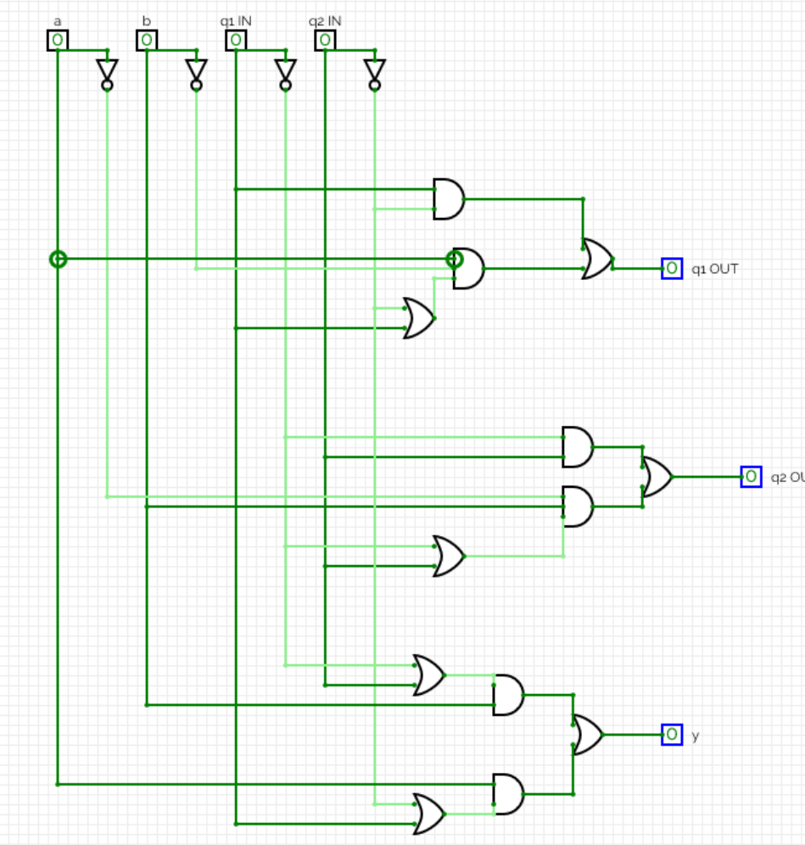

# Zadanie 2

Zaprojektować układ, który w k-bitowym ciągu wejściowym wykrywa grupy sąsiadujących ze sobą jedynek (co najmniej trzech) i na wyjściu zastępuje je zerami. Na pozostałych pozycjach mają być jedynki. Układy tego typu mogą być stosowane do sterowania wielostanowiskowymi systemami obsługi. Wykrywają nadmierne zagęszczenie zgłoszeń w pewnych rejonach i zamykają chwilowo dostęp do tych stanowisk.

|  |  |  |  |  |  |  |  |  |
| --- | --- | --- | --- | --- | --- | --- | --- | --- |
| Lp | a | q IN | p1 IN | p2 IN | y | q OUT | p1 OUT | p2 OUT |
| 0 | 0 | 0 | 0 | 0 | 1 | 0 | 0 | 0 |
| 1 | 0 | 0 | 0 | 1 | 1 | 0 | 0 | 0 |
| 2 | 0 | 0 | 1 | 0 | 1 | 0 | 0 | 0 |
| 3 | 0 | 0 | 1 | 1 | 1 | 1 | 0 | 0 |
| 4 | 0 | 1 | 0 | 0 | - | - | - | - |
| 5 | 0 | 1 | 0 | 1 | - | - | - | - |
| 6 | 0 | 1 | 1 | 0 | - | - | - | - |
| 7 | 0 | 1 | 1 | 1 | - | - | - | - |
| 8 | 1 | 0 | 0 | 0 | 1 | 0 | 0 | 1 |
| 9 | 1 | 0 | 0 | 1 | 1 | 0 | 1 | 0 |
| 10 | 1 | 0 | 1 | 0 | 0 | 1 | 1 | 1 |
| 11 | 1 | 0 | 1 | 1 | 0 | 1 | 1 | 1 |
| 12 | 1 | 1 | 0 | 0 | 0 | 0 | 0 | 1 |
| 13 | 1 | 1 | 0 | 1 | 0 | 1 | 1 | 0 |
| 14 | 1 | 1 | 1 | 0 | 0 | 1 | 1 | 1 |
| 15 | 1 | 1 | 1 | 1 | 0 | 1 | 1 | 1 |

|  |  |  |  |  |
| --- | --- | --- | --- | --- |
| ab\q1q2 | 00 | 01 | 11 | 10 |
| 00 | 1 | 1 | 1 | 1 |
| 01 | - | - | - | - |
| 11 | 0 | 0 | 0 | 0 |
| 10 | 1 | 1 | 0 | 0 |
| !A + !q*!p1 | | | | |

|  |  |  |  |  |
| --- | --- | --- | --- | --- |
| ab\q1q2 | 00 | 01 | 11 | 10 |
| 00 | 0 | 0 | 1 | 0 |
| 01 | - | - | - | - |
| 11 | 0 | 1 | 1 | 1 |
| 10 | 0 | 0 | 1 | 1 |
| p1*p2 + q*p + A*p1 | | | | |

|  |  |  |  |  |
| --- | --- | --- | --- | --- |
| ab\q1q2 | 00 | 01 | 11 | 10 |
| 00 | 0 | 0 | 0 | 0 |
| 01 | - | - | - | - |
| 11 | 1 | 0 | 1 | 1 |
| 10 | 1 | 0 | 1 | 1 |
| A*p1 + A*!p2 | | | | |

|  |  |  |  |  |
| --- | --- | --- | --- | --- |
| ab\q1q2 | 00 | 01 | 11 | 10 |
| 00 | 0 | 0 | 0 | 0 |
| 01 | - | - | - | - |
| 11 | 1 | 0 | 1 | 1 |
| 10 | 1 | 0 | 1 | 1 |
| A*p1 + A*!p2 | | | | |

